**Project Design Phase-II**

**Data flow diagrams and user stories**

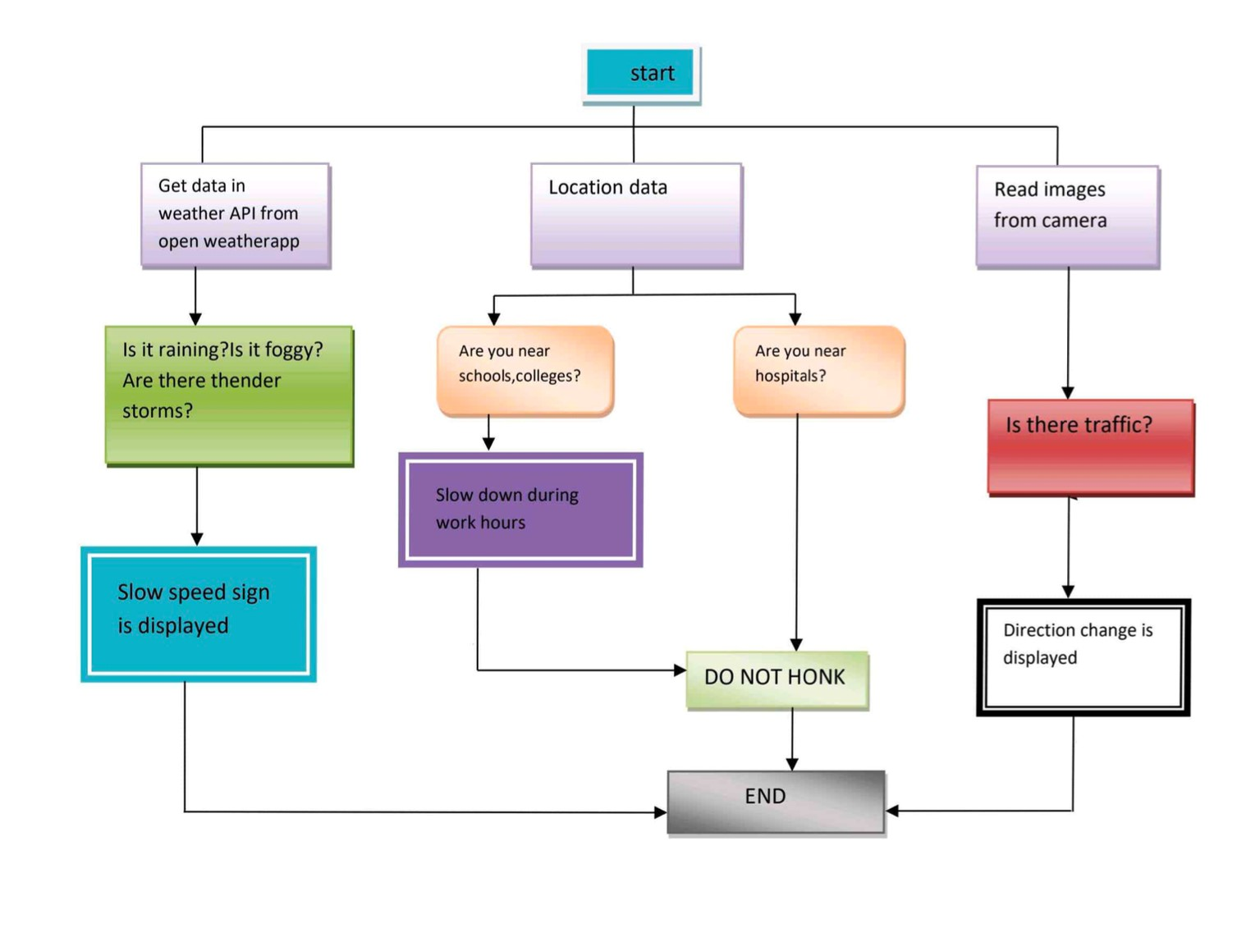

|  |  |
| --- | --- |
| Date | 13 October 2022 |
| Team ID | PNT2022TMID24762 |
| Project Name | Project- Signs with Smart Connectivity for Better Road Safety |
| Maximum marks | 4 marks |

**Data Flow Diagram:**

**User Stories:**

